Infortec international-Nugegoda | HDCS |

PHP MySQL Assignment

by D. tharindu Dhanushka mahawatta

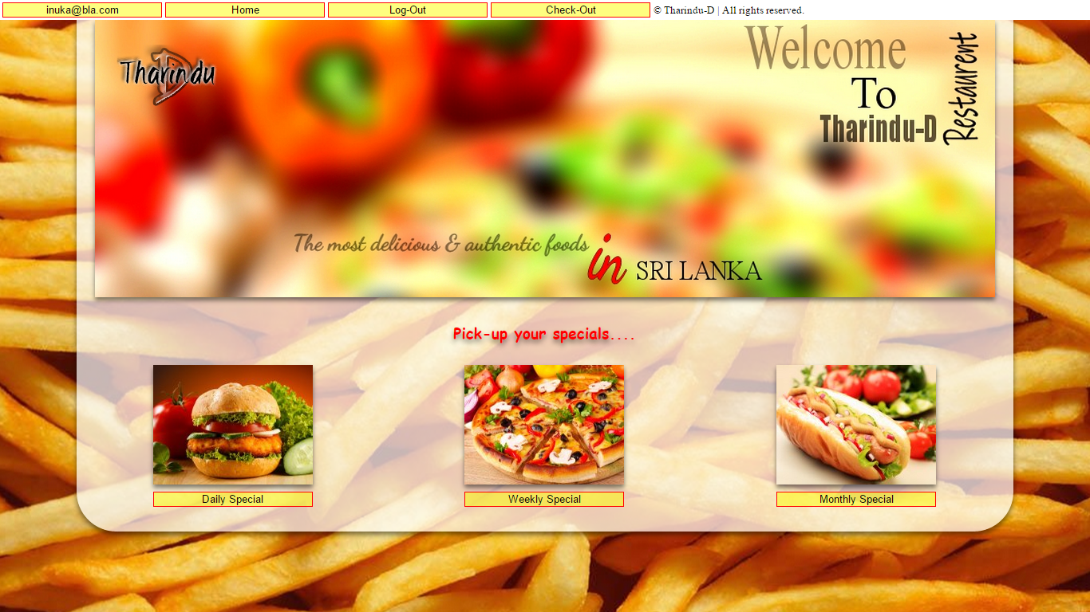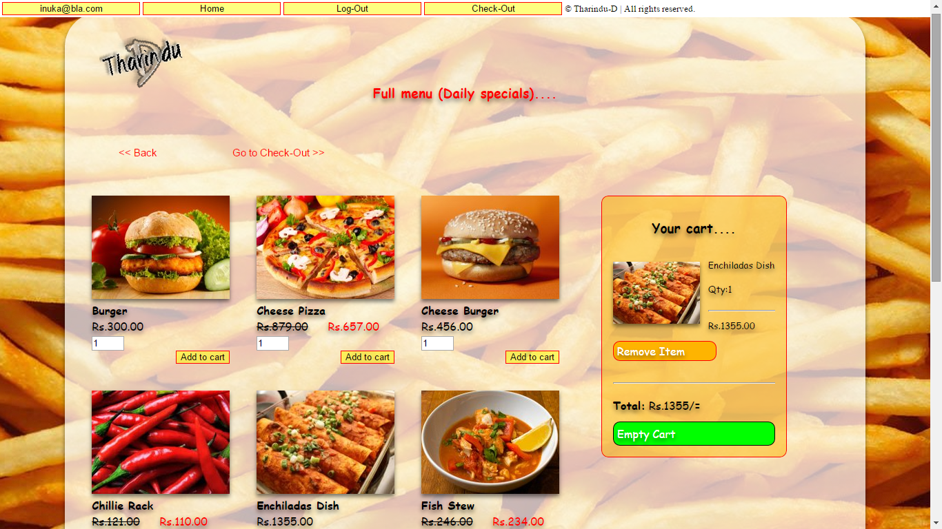

**Attachment No 001**

Assignment Marking Scheme- **HDCS-AS16-ACA**

**(For the use of officers only)**

|  |  |  |  |
| --- | --- | --- | --- |
| Allocation of Marks **Area of evaluation** | **Weightage** | | **Marks Awarded** |
| Designing of Web Pages | | 20% | |
| Database Architecture  1. Assigning Privileges  2. Identifying Primary keys & Foreign keys  3. Identifying Relationships | | 20% | |
| Creating Queries  1. Insert  2. Select  3. Update  4. Delete | | 10% | |
| Handling Process  1. Using PHP+MySQL  2. Using JS, HTML/CSS | | 20% | |
| Quality of Documentation | | 10% | |
| Oral Test | | 20% | |
| Final Marks of Evaluation | | | |
| Overall comments by the officer | | | |

**Signature of Officer and Date:……………………………….**

**IMPORTANT: This should be attached to the assignment as the after the cover page.**

**Contains….**

1. **Introduction**
2. **Student details**
3. **Design interfaces**
4. **HTML/CSS/JS/MySQL coding**
5. Database architecture

***PS: This assignment’s softcopy attached with this document.***

***Introduction***

Welcome to my shopping cart project!

This is my 2nd PHP project (first one is login form) and 1st PHP assignment

The shopping cart is a series of pages that are all linked together through some sort of programming (usually JS and PHP) that allows data to be transferred along with the viewer from page to page.

In this assignment I have to learn some basics about OOP concept of PHP5 and also have to learn foreach loop to get each element from an array.

In this assignment when you entered to shopping cart (/SC/index.php) you must Login to the system first. Otherwise cart will automatically redirect to the login page.

This system already has following accounts….

[inuka@bla.com](mailto:inuka@bla.com)

[keshawa@bla.com](mailto:keshawa@bla.com)

[kasun@bla.com](mailto:kasun@bla.com)

**PS: “bla” is the default password of above accounts.**

Now you are ready for the shopping…

***Student details….***

***Name: D. Tharindu Dhanushka Mahawatta***

***St no: 14NU0240***

***Batch: 13/14 MID part time (HDCS)***

***Design interfaces:***

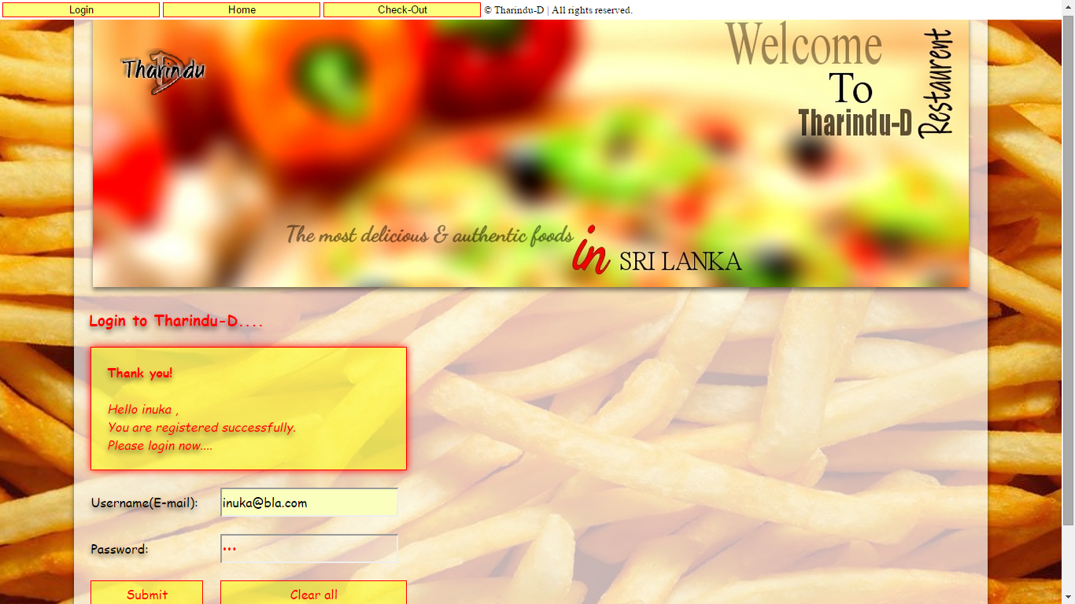



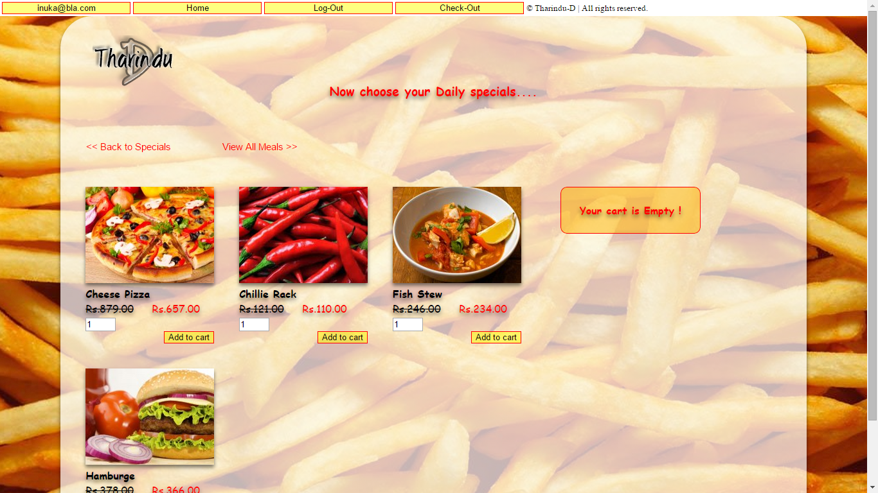



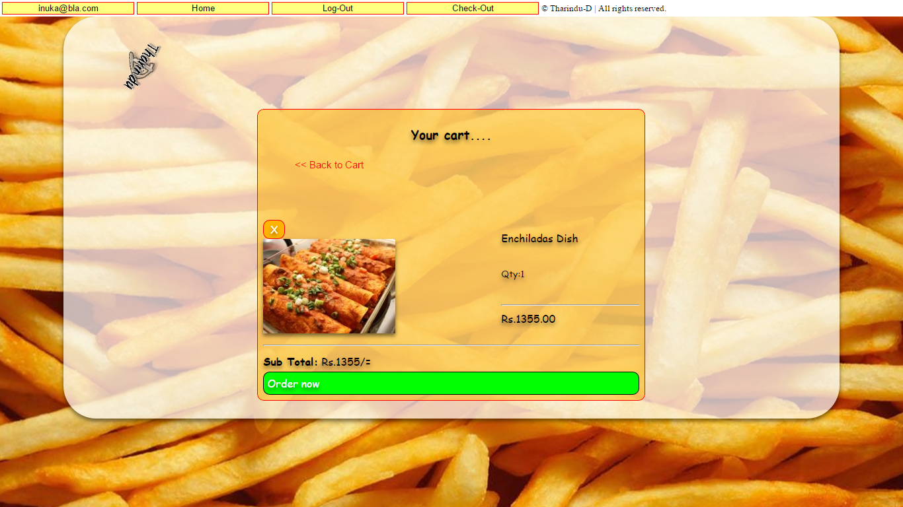

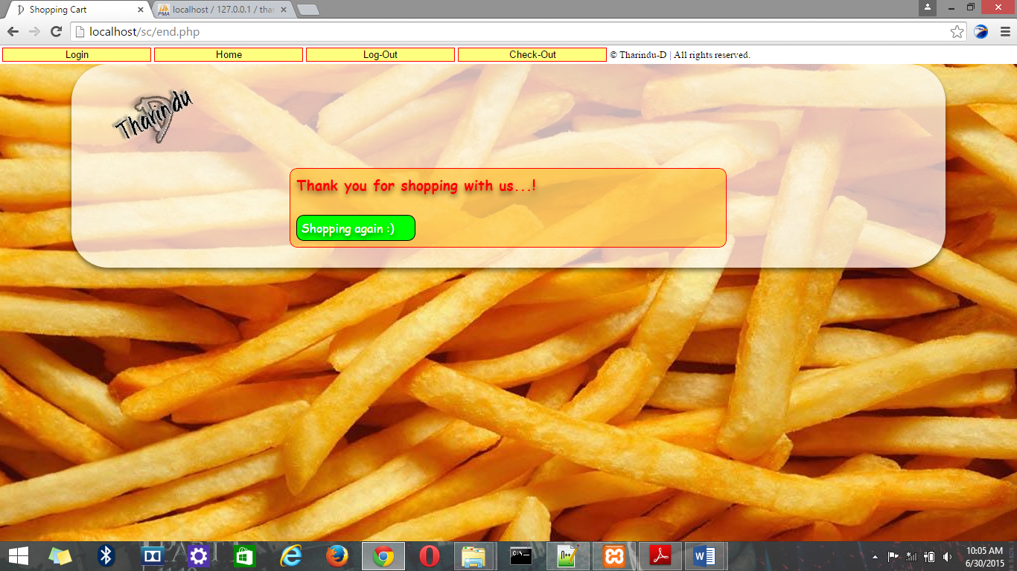

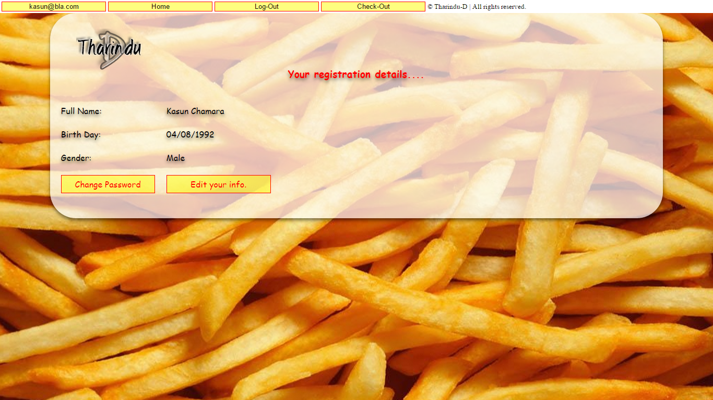

***All codings…***

***Index.php***

<!--Tharindu-D Shopping cart-->

<!--

<?php

session_start();

//if not login user redirect to login page

if(!isset($_SESSION['log']))

{

$un = Login ;

}else

{

$un = $_SESSION['log'] ;

}

//set session to specified special

if(isset($_POST['Daily_s']))

{

$_SESSION['special'] = "Daily";

header('Location:sp_cart.php');

}

if(isset($_POST['Weekly_s']))

{

$_SESSION['special'] = "Weekly";

header('Location:sp_cart.php');

}

if(isset($_POST['Monthly_s']))

{

$_SESSION['special'] = "Monthly";

header('Location:sp_cart.php');

}

//nav bar sessions

if(isset($_GET['user']))

{

header('Location:users/profile.php');

}

if(isset($_GET['home']))

{

unset($_SESSION['special']);

header('Location:index.php');

}

if(isset($_GET['l-out']))

{

session_destroy();

header('Location:users/login.php');

}

if(isset($_GET['c-out']))

{

header('Location:c-out.php');

}

?>

-->

<!DOCTYPE html>

<!--Created by Tharindu-D -->

<html>

<head>

<meta http-equiv="Content-Type" content="text/html; charset=utf-8" />

<link rel="SHORTCUT ICON" href="icon/icon.ico" type="image/x-icon" />

<title>Shopping Cart</title>

<link href="style/main.css" rel="stylesheet" type="text/css">

</head>

<body>

<nav class="nav">

<table>

<tr>

<td><div id="btn"><form method='get'><input type='submit' name="user" value='<?php echo $un ; ?>'></form></div></td>

<td><div id="btn"><form method='get'><input type='submit' name="home" value='Home'></form></div></td>

<?php

if(isset($_SESSION['log']))

{

echo '<td><div id="btn"><form method="get"><input type="submit" name="l-out" value="Log-Out"></form></div></td>';

}

?>

<td><div id="btn"><form method='get'><input type='submit' name="c-out" value='Check-Out'></form></div></td>

<td><small>&copy;&nbsp;Tharindu-D | All rights reserved.</small></td>

</tr>

</table>

</nav>

<div id="bg1">

<!--Tharindu-D logo-->

<div id="banner" >

<img src="icon/banner.jpg" alt="banner" ><br/>

</div>

<table id="cart">

<!--Created by Tharindu-D -->

<tr>

<td colspan="3"><font color="red"><big><b>Pick-up your specials....</b></big></font><br/>&nbsp;</td>

</tr>

<tr>

<td><img src="foods/burger.jpg" alt="Daily Special" width="200px" height="150px"><br />

<div id="btn"><form method='post'><input type='submit' name="Daily_s" value='Daily Special'></form></div></td>

<td><img src="foods/cheese-pizza.jpg" alt="Weekly Special" width="200px" height="150px"><br />

<div id="btn"><form method='post'><input type='submit' name="Weekly_s" value='Weekly Special'></form></div></td>

<td><img src="foods/hotdog.jpg" alt="Monthly Special" width="200px" height="150px"><br />

<div id="btn"><form method='post'><input type='submit' name="Monthly_s" value='Monthly Special'></form></div></td>

</tr>

</table>

</div>

</body>

</html>

***sp_cart.php***

<!--Tharindu-D Shopping cart POWERED by PHP[v5]/OOP | Copyrights Tharindu-D | All rights reserved-->

<!--

<?php

session_start();

include_once("conman.php");

if(!isset($_SESSION['log']))

{

$_SESSION['alert'] = "You must login first !";

$un = Login ;

header('Location:users/login.php');

}

$un = $_SESSION['log'] ;

if(!isset($_SESSION['special']))

{

header('Location:index.php');

}

if(isset($_SESSION['special']))

{

$sp = $_SESSION['special'];

}

//nav bar sessions

if(isset($_GET['user']))

{

header('Location:users/profile.php');

}

if(isset($_GET['home']))

{

unset($_SESSION['special']);

header('Location:index.php');

}

if(isset($_GET['l-out']))

{

session_destroy();

header('Location:users/login.php');

}

if(isset($_GET['c-out']))

{

header('Location:c-out.php');

}

//if press back to special

if(isset($_POST['back']))

{

unset($_SESSION['special']);

unset($_SESSION['meals']);

header('Location:index.php');

}

if(isset($_POST['all']))

{

header('Location:sup_cart.php');

} ?> -->

<!DOCTYPE html>

<!--Created by Tharindu-D -->

<html>

<head>

<meta http-equiv="Content-Type" content="text/html; charset=utf-8" />

<link rel="SHORTCUT ICON" href="icon/icon.ico" type="image/x-icon" />

<title>Shopping Cart</title>

<link href="style/main.css" rel="stylesheet" type="text/css">

</head>

<body>

<nav class="nav">

<table>

<tr>

<td><div id="btn"><form method='get'><input type='submit' name="user" value='<?php echo $un ; ?>'></form></div></td>

<td><div id="btn"><form method='get'><input type='submit' name="home" value='Home'></form></div></td>

<?php

if(isset($_SESSION['log']))

{

echo '<td><div id="btn"><form method="get"><input type="submit" name="l-out" value="Log-Out"></form></div></td>';

}

?>

<td><div id="btn"><form method='get'><input type='submit' name="c-out" value='Check-Out'></form></div></td>

<td><small>&copy;&nbsp;Tharindu-D | All rights reserved.</small></td>

</tr>

</table>

</nav>

<div id="bg">

<!--Tharindu-D logo-->

<table id="cart" style="padding-top : 100px ;">

<!--Created by Tharindu-D -->

<tr>

<td colspan="3"><font color="red"><big><b>Now choose your <?php echo $sp ; ?> specials....</b></big></font></td>

</tr>

<tr>

<td colspan="3">

<table id="tb_back">

<tr><td colspan = '2'>&nbsp;</td></tr><tr><td colspan = '2'>&nbsp;</td></tr>

<tr>

<td><div id="btn_back"><form method='post'><input type='submit' name="back" value='<< Back to Specials'></form></div><br/>&nbsp;</td>

<td><div id="btn_back"><form method='post'><input type='submit' name="all" value='View All Meals >>'></form></div><br/>&nbsp;</td>

</tr>

</table>

</td>

</tr>

</table>

<div width="100%" >

<div style="float : left ; width : 67% ;">

<?php

//current URL of the Page cart_update.php redirects back to this URL

$current_url = base64_encode($url="http://".$_SERVER['HTTP_HOST'].$_SERVER['REQUEST_URI']);

$results = $mysqli->query("SELECT * FROM `rest` WHERE sp ='".$sp."'");

//fetch results set as object and output HTML

while($obj = $results->fetch_object())

{

echo '<div class="food">';

echo '<form method="post" action="cart_update.php">';

echo '<img src="foods/'.$obj->image.'" alt="Daily Special" width="200px" height="150px"><br />';

echo '<strong>'.$obj->name.'</strong><br />';

echo '<strike>Rs.'.$obj->price.'</strike> &nbsp;&nbsp;&nbsp;&nbsp; ';

echo '<font color="red">Rs.'.$obj->sp_price.'</font> <br />';

echo '<input type="text" name="meal_qty" value="1" size="2" />';

echo '<div id="c_btn"><input type="submit" value="Add to cart"/></div>';

echo '<input type="hidden" name="code" value="'.$obj->code.'" />';

echo '<input type="hidden" name="type" value="add" />';

echo '<input type="hidden" name="return_url" value="'.$current_url.'" />';

echo '</form>';

echo '</div>';

}

?>

</div>

<div style="float : left ;">

<table id="add_cart" width="100%" >

<?php

if(isset($_SESSION["meals"]))

{

$total = 0;

echo "

<tr>

<th colspan = '2'>

<p><big>Your cart....</big></p>

</th>

</tr>

";

foreach ($_SESSION["meals"] as $cart_itm)

{

echo '<tr><td rowspan = "3"><img src="foods/'.$cart_itm["image"].'" height="90px"></td>' ;

echo '<td><small>'.$cart_itm["name"].'</small></td></tr>';

echo '<tr><td><small>Qty:'.$cart_itm["qty"].'</small></td></tr>';

echo '<tr><td><hr><small><font color="red">Rs.'.$cart_itm["sp_price"].'</font></small></td></tr>';

echo '<tr><td colspan="2">';

echo '<div id="b_btn"><a href="cart_update.php?removep='.$cart_itm["code"].'&return_url='.$current_url.'">Remove Item</a></div><br/><hr />';

echo '</tr></td>';

$subtotal = ($cart_itm["sp_price"]*$cart_itm["qty"]);

$total = ($total + $subtotal);

}

echo '<tr><td colspan="2">';

echo '<strong>Total:</strong> Rs.'.$total.'/=';

echo '</tr></td>';

echo '<tr><td colspan="2"><div id="a_btn"><a href="cart_update.php?emptycart=1&return_url='.$current_url.'">Empty Cart</a></div></td></tr></table>';

}else

{

echo "

<tr>

<th colspan = '2' width='200px'>

<p><font color='red'>Your cart is Empty !</font></p>

</th>

</tr>

</table>

";

}

?> </div></div></div></body></html>

***sup_cart.php***

<!--Tharindu-D Shopping cart POWERED by PHP[v5]/OOP | Copyrights Tharindu-D | All rights reserved-->

<!--

<?php

session_start();

include_once("conman.php");

if(!isset($_SESSION['log']))

{

header('Location:users/login.php');

}

$un = $_SESSION['log'] ;

if(!isset($_SESSION['special']))

{

header('Location:index.php');

}

$sp = $_SESSION['special'];

//nav bar sessions

if(isset($_GET['user']))

{

header('Location:users/profile.php');

}

if(isset($_GET['home']))

{

unset($_SESSION['special']);

header('Location:index.php');

}

if(isset($_GET['l-out']))

{

session_destroy();

header('Location:users/login.php');

}

if(isset($_GET['c-out']))

{

header('Location:c-out.php');

}

//if press "back to special"

if(isset($_POST['back']))

{

header('Location:sp_cart.php');

}

if(isset($_POST['c-out']))

{

header('Location:c-out.php');

} ?> -->

<!DOCTYPE html>

<!--Created by Tharindu-D -->

<html>

<head>

<meta http-equiv="Content-Type" content="text/html; charset=utf-8" />

<link rel="SHORTCUT ICON" href="icon/icon.ico" type="image/x-icon" />

<title>Shopping Cart</title>

<link href="style/main.css" rel="stylesheet" type="text/css">

</head>

<body>

<nav class="nav">

<table>

<tr>

<td><div id="btn"><form method='get'><input type='submit' name="user" value='<?php echo $un ; ?>'></form></div></td>

<td><div id="btn"><form method='get'><input type='submit' name="home" value='Home'></form></div></td>

<?php

if(isset($_SESSION['log']))

{

echo '<td><div id="btn"><form method="get"><input type="submit" name="l-out" value="Log-Out"></form></div></td>';

}

?>

<td><div id="btn"><form method='get'><input type='submit' name="c-out" value='Check-Out'></form></div></td>

<td><small>&copy;&nbsp;Tharindu-D | All rights reserved.</small></td>

</tr></table></nav>

<div id="bg">

<!--Tharindu-D logo-->

<table id="cart" style="padding-top : 100px ;">

<!--Created by Tharindu-D -->

<tr>

<td colspan="3"><font color="red"><big><b>Full menu (<?php echo $sp ; ?> specials)....</b></big></font></td>

</tr>

<tr>

<td colspan="3">

<table id="tb_back">

<tr><td colspan = '2'>&nbsp;</td></tr><tr><td colspan = '2'>&nbsp;</td></tr>

<tr>

<td><div id="btn_back"><form method='post'><input type='submit' name="back" value='<< Back'></form></div><br/>&nbsp;</td>

<td><div id="btn_back"><form method='post'><input type='submit' name="c-out" value='Go to Check-Out >>'></form></div><br/>&nbsp;</td>

</tr>

</table>

</td>

</tr>

</table>

<div width="100%" >

<div style="float : left ; width : 67% ;">

<?php

//current URL of the Page cart_update.php redirects back to this URL

$current_url = base64_encode($url="http://".$_SERVER['HTTP_HOST'].$_SERVER['REQUEST_URI']);

$results = $mysqli->query("SELECT * FROM `rest` ORDER BY id ASC");

//fetch results set as object and output HTML

while($obj = $results->fetch_object())

{

echo '<div class="food">';

echo '<form method="post" action="cart_update.php">';

echo '<img src="foods/'.$obj->image.'" alt="Daily Special" width="200px" height="150px"><br />';

echo '<strong>'.$obj->name.'</strong><br />';

if($sp==$obj->sp)

{

echo '<strike>Rs.'.$obj->price.'</strike> &nbsp;&nbsp;&nbsp;&nbsp; ';

echo '<font color="red">Rs.'.$obj->sp_price.'</font> <br />';

}else

{

echo 'Rs.'.$obj->price.'<br />';

}

echo '<input type="text" name="meal_qty" value="1" size="2" />';

echo '<div id="c_btn"><input type="submit" value="Add to cart"/></div>';

echo '<input type="hidden" name="code" value="'.$obj->code.'" />';

echo '<input type="hidden" name="type" value="add" />';

echo '<input type="hidden" name="return_url" value="'.$current_url.'" />';

echo '</form>';

echo '</div>';

}

?>

</div>

<div style="float : left ;">

<table id="add_cart" width="100%" cellspacing="10">

<?php

if(isset($_SESSION["meals"]))

{

$total = 0;

echo "

<tr>

<th colspan = '2'>

<p><big>Your cart....</big></p>

</th>

</tr>

";

foreach ($_SESSION["meals"] as $cart_itm)

{

echo '<tr><td rowspan = "3"><img src="foods/'.$cart_itm["image"].'" height="90px"></td>' ;

echo '<td><small>'.$cart_itm["name"].'</small></td></tr>';

echo '<tr><td><small>Qty:'.$cart_itm["qty"].'</small></td></tr>';

if($sp==$cart_itm["sp"])

{

echo '<tr><td><hr><small><font color="red">Rs.'.$cart_itm["sp_price"].'</font></small></td></tr>';

}else

{

echo '<tr><td><hr><small>Rs.'.$cart_itm["price"].'</small></td></tr>';

}

echo '<tr><td colspan="2">';

echo '<div id="b_btn"><a href="cart_update.php?removep='.$cart_itm["code"].'&return_url='.$current_url.'">Remove Item</a></div><br/><hr />';

echo '</tr></td>';

if($sp==$cart_itm["sp"])

{

$subtotal = ($cart_itm["sp_price"]*$cart_itm["qty"]);

}else

{

$subtotal = ($cart_itm["price"]*$cart_itm["qty"]);

}

$total = ($total + $subtotal);

}

echo '<tr><td colspan="2">';

echo '<strong>Total:</strong> Rs.'.$total.'/=';

echo '</tr></td>';

echo '<tr><td colspan="2"><div id="a_btn"><a href="cart_update.php?emptycart=1&return_url='.$current_url.'">Empty Cart</a></div></td></tr></table>';

}else

{

echo "

<tr>

<th colspan = '2' width='200px'>

<p><font color='red'>Your cart is Empty !</font></p>

</th>

</tr>

</table>

";

}

?>

</div>

</div>

</div>

</body>

</html>

***c-out.php***

<!--Tharindu-D Shopping cart POWERED by PHP[v5]/OOP | Copyrights Tharindu-D | All rights reserved-->

<!--

<?php

session_start();

include_once("conman.php");

if(!isset($_SESSION['log']))

{

header('Location:users/login.php');

}

$un = $_SESSION['log'] ;

if(!isset($_SESSION['special']))

{

header('Location:index.php');

}

$sp = $_SESSION['special'];

//nav bar sessions

if(isset($_GET['user']))

{

header('Location:users/profile.php');

}

if(isset($_GET['home']))

{

unset($_SESSION['special']);

header('Location:index.php');

}

if(isset($_GET['l-out']))

{

session_destroy();

header('Location:users/login.php');

}

if(isset($_GET['c-out']))

{

header('Location:c-out.php');

}

//if press "back to Cart"

if(isset($_POST['back']))

{

header('Location:sup_cart.php');

}

?>

-->

<!DOCTYPE html>

<!--Created by Tharindu-D -->

<html>

<head>

<meta http-equiv="Content-Type" content="text/html; charset=utf-8" />

<link rel="SHORTCUT ICON" href="icon/icon.ico" type="image/x-icon" />

<title>Shopping Cart</title>

<link href="style/main.css" rel="stylesheet" type="text/css">

</head>

<body>

<nav class="nav">

<table>

<tr>

<td><div id="btn"><form method='get'><input type='submit' name="user" value='<?php echo $un ; ?>'></form></div></td>

<td><div id="btn"><form method='get'><input type='submit' name="home" value='Home'></form></div></td>

<?php

if(isset($_SESSION['log']))

{

echo '<td><div id="btn"><form method="get"><input type="submit" name="l-out" value="Log-Out"></form></div></td>';

}

?>

<td><div id="btn"><form method='get'><input type='submit' name="c-out" value='Check-Out'></form></div></td>

<td><small>&copy;&nbsp;Tharindu-D | All rights reserved.</small></td>

</tr>

</table>

</nav>

<div id="bg">

<!--Tharindu-D logo-->

<table id="add_cart" style="margin-top : 140px ; margin-left : 25% ; margin-right : 25% ;" width="50%" >

<?php

//current URL of the Page cart_update.php redirects back to this URL

$current_url = base64_encode($url="http://".$_SERVER['HTTP_HOST'].$_SERVER['REQUEST_URI']);

if(isset($_SESSION["meals"]))

{

$total = 0;

echo " <tr>

<th colspan = '2'>

<p><big>Your cart....</big></p>

</th></tr><tr>td>

<div id='btn_back'><form method='post'><input type='submit' name='back' value='<< Back to Cart'></form></div><br/>&nbsp;</td><td></td>

</tr>

";

foreach ($_SESSION["meals"] as $cart_itm)

{

echo '<tr><td rowspan = "3">

<br/><div id="b_btn" style="width:40px !important ;"><a href="cart_update.php?removep='.$cart_itm["code"].'&return_url='.$current_url.'">&nbsp;X</a></div>

<img src="foods/'.$cart_itm["image"].'"></td>' ;

echo '<td><br>'.$cart_itm["name"].'</td></tr>';

echo '<tr><td><small>Qty:'.$cart_itm["qty"].'</small></td></tr>';

if($sp==$cart_itm["sp"])

{

echo '<tr><td><hr><font color="red">Rs.'.$cart_itm["sp_price"].'</font></td></tr>';

}else

{

echo '<tr><td><hr>Rs.'.$cart_itm["price"].'</td></tr>';

echo '<tr><td colspan = "2"><hr /></td></tr>';

}

if($sp==$cart_itm["sp"])

{

$subtotal = ($cart_itm["sp_price"]*$cart_itm["qty"]);

}else

{

$subtotal = ($cart_itm["price"]*$cart_itm["qty"]);

}

$total = ($total + $subtotal);

}

echo '<tr><td colspan="2">';

echo '<strong>Sub Total:</strong> Rs.'.$total.'/=';

echo '</tr></td>';

echo '<tr><td colspan="2"><div id="a_btn"><a href="end.php" >Order now</a></div></td></tr></table>';

}else

{

echo "

<tr>

<th colspan = '2' width='200px'>

<p><font color='red'>Your cart is Empty !</font></p>

</th>

</tr>

</table>

";

}

?>

</div>

</body>

</html>

***End.php***

<!--Tharindu-D Shopping cart POWERED by PHP[v5]/OOP | Copyrights Tharindu-D | All rights reserved-->

<!--

<?php

session_start();

include_once("conman.php");

session_destroy();

$un = "Login";

//nav bar sessions

if(isset($_GET['user']))

{

header('Location:users/profile.php');

}

if(isset($_GET['home']))

{

unset($_SESSION['special']);

header('Location:index.php');

}

if(isset($_GET['l-out']))

{

session_destroy();

header('Location:users/login.php');

}

if(isset($_GET['c-out']))

{

header('Location:c-out.php');

}

//if press "back to Cart"

if(isset($_POST['back']))

{

header('Location:sup_cart.php');

}

?>

-->

<!DOCTYPE html>

<!--Created by Tharindu-D -->

<html>

<head>

<meta http-equiv="Content-Type" content="text/html; charset=utf-8" />

<link rel="SHORTCUT ICON" href="icon/icon.ico" type="image/x-icon" />

<title>Shopping Cart</title>

<link href="style/main.css" rel="stylesheet" type="text/css">

</head>

<body>

<nav class="nav">

<table>

<tr>

<td><div id="btn"><form method='get'><input type='submit' name="user" value='<?php echo $un ; ?>'></form></div></td>

<td><div id="btn"><form method='get'><input type='submit' name="home" value='Home'></form></div></td>

<?php

if(isset($_SESSION['log']))

{

echo '<td><div id="btn"><form method="get"><input type="submit" name="l-out" value="Log-Out"></form></div></td>';

}

?>

<td><div id="btn"><form method='get'><input type='submit' name="c-out" value='Check-Out'></form></div></td>

<td><small>&copy;&nbsp;Tharindu-D | All rights reserved.</small></td>

</tr>

</table>

</nav>

<div id="bg">

<!--Tharindu-D logo-->

<table id="add_cart" style="margin-top : 140px ; margin-left : 25% ; margin-right : 25% ;" width="50%" >

<tr>

<td colspan="2"><font color="red"><b><big>Thank you for shopping with us...!<br /></big></b></font></td>

</tr>

<tr>

<td><br /><div id="a_btn" style="width : 160px !important ; "><a href="index.php" >Shopping again :)</a></div></td>

<td></td>

</tr>

</table>

</div>

</body>

</html>

***Login part..***

***login.php***

<!--Tharindu-D Shopping cart-->

<!--

<?php

session_start();

if(!isset($_SESSION['log']))

{

$un = "Login" ;

}

else

{

$un = $_SESSION['log'] ;

}

//nav bar sessions

if(isset($_GET['user']))

{

unset($_SESSION['reg']);

unset($_SESSION['alert']);

header('Location:profile.php');

}

if(isset($_GET['home']))

{

unset($_SESSION['reg']);

unset($_SESSION['alert']);

header('Location:../index.php');

}

if(isset($_GET['l-out']))

{

session_destroy();

header('Location:login.php');

}

if(isset($_GET['c-out']))

{

unset($_SESSION['reg']);

unset($_SESSION['alert']);

header('Location:../c-out.php');

}

//if press submit button

if(isset($_POST['sub']))

{

unset($_SESSION['reg']);

unset($_SESSION['alert']);

include('conman.php');

$un = mysql_real_escape_string($_POST['email']);

$pw = mysql_real_escape_string($_POST['pass']);

$pwE = md5($pw);

$sql = mysql_query("SELECT * FROM log WHERE username='$un' AND pass='$pwE'") or die("Query Error : ".mysql_error());

if(mysql_num_rows($sql)==1)

{

$_SESSION['log'] = $un;

header('Location:../index.php');

}

else

{

$_SESSION['alert'] = "Incorrect username or password!";

}

}

?>

-->

<!DOCTYPE html>

<!--Created by Tharindu-D -->

<html>

<head>

<meta http-equiv="Content-Type" content="text/html; charset=utf-8" />

<link rel="SHORTCUT ICON" href="../icon/icon.ico" type="image/x-icon" />

<title>Shopping Cart</title>

<link rel="stylesheet" href="../style/main.css" type="text/css">

<link rel="stylesheet" href="css/users.css" type="text/css" />

</head>

<body>

<nav class="nav">

<table>

<tr>

<td><div id="btn"><form method='get'><input type='submit' name="user" value='<?php echo $un ; ?>'></form></div></td>

<td><div id="btn"><form method='get'><input type='submit' name="home" value='Home'></form></div></td>

<?php

if(isset($_SESSION['log']))

{

echo '<td><div id="btn"><form method="get"><input type="submit" name="l-out" value="Log-Out"></form></div></td>';

}

?>

<td><div id="btn"><form method='get'><input type='submit' name="c-out" value='Check-Out'></form></div></td>

<td><small>&copy;&nbsp;Tharindu-D | All rights reserved.</small></td>

</tr>

</table>

</nav>

<div id="bg1">

<!--Tharindu-D logo-->

<div id="banner" >

<img src="../icon/banner.jpg" alt="banner" ><br/>

</div>

&nbsp;&nbsp;&nbsp;&nbsp;<font color="red"><big><b>Login to Tharindu-D....</b></big></font>

<form action="" method='post' id='contact_form'>

<table cellspacing="20" >

<tr>

<td colspan="2">

<?php

if(isset($_SESSION['reg']))

{

echo ("<div id='banner1'><strong>Thank you!</strong><br /><br /><i>Hello ".$_SESSION['reg']." ,<br />You are registered successfully.<br />Please login now....</i></div>");

}

?>

<?php

if(isset($_SESSION['alert']))

{

echo "<div id='banner1' align='center'>".$_SESSION['alert']."</div>";

} ?>

</td>

</tr> <tr>

<td>Username(E-mail):</td>

<td><div id="btni"><input type='text' name='email' id='name'></div></td>

</tr><tr>

<td>Password:</td>

<td><div id="btni"><input type='password' name='pass' id='name'></div></td>

</tr><tr>

<td><div id="btnl"><input type='submit' name="sub" value='Submit'></div></td>

<td><div id="btnl"><input type='reset' value='Clear all'></div></td>

</tr><tr>

<td colspan = "2"><a href="reg.php"><small><b>Not yet registered?</b></small></a></td>

</tr>

</table>

</form>

</div>

</body>

</html>

***Reg.php***

<!--Tharindu-D Shopping cart POWERED by PHP[v5]/OOP | Copyrights Tharindu-D | All rights reserved-->

<!--

<?php

session_start();

include_once("config.php");

if(!isset($_SESSION['log']))

{

$un = "Login" ;

}

$un = $_SESSION['log'] ;

//nav bar sessions

if(isset($_GET['user']))

{

unset($_SESSION['reg']);

unset($_SESSION['alert']);

header('Location:profile.php');

}

if(isset($_GET['home']))

{

unset($_SESSION['reg']);

unset($_SESSION['alert']);

header('Location:../index.php');

}

if(isset($_GET['l-out']))

{

session_destroy();

header('Location:login.php');

}

if(isset($_GET['c-out']))

{

unset($_SESSION['reg']);

unset($_SESSION['alert']);

header('Location:../c-out.php');

}

?>

-->

<!DOCTYPE html>

<!--Created by Tharindu-D -->

<html>

<head>

<meta http-equiv="Content-Type" content="text/html; charset=utf-8" />

<link rel="SHORTCUT ICON" href="../icon/icon.ico" type="image/x-icon" />

<title>Shopping Cart</title>

<link rel="stylesheet" href="../style/main.css" type="text/css">

<link rel="stylesheet" href="css/users.css" type="text/css" />

<script type="text/javascript" src="js/jquery-1.3.2.min.js"></script>

<script type="text/javascript" src="js/mail.js"></script>

</head>

<body>

<nav class="nav">

<table>

<tr>

<td><div id="btn"><form method='get'><input type='submit' name="user" value='<?php echo $un ; ?>'></form></div></td>

<td><div id="btn"><form method='get'><input type='submit' name="home" value='Home'></form></div></td>

<?php

if(isset($_SESSION['log']))

{

echo '<td><div id="btn"><form method="get"><input type="submit" name="l-out" value="Log-Out"></form></div></td>';

} ?>

<td><div id="btn"><form method='get'><input type='submit' name="c-out" value='Check-Out'></form></div></td>

<td><small>&copy;&nbsp;Tharindu-D | All rights reserved.</small></td>

</tr></table></nav>

<div id="bg">

<!--Tharindu-D logo-->

<table id="cart" style="padding-top : 100px ;">

<!--Created by Tharindu-D -->

<tr>

<td colspan="3"><font color="red"><big><b>Be a part of us....</b></big></font></td>

</tr>

</table>

<div id="btni" width="100%" >

<form action="check.php" method='post' onSubmit="return checkform();" >

<table cellspacing="20" >

<tr>

<td colspan="2">

<?php

if(isset($_SESSION['reg']))

{

echo "<div id='banner1' align='center'>".$_SESSION['reg']."</div>";

} ?>

</td>

</tr>

<tr>

<td>First Name:</td>

<td><input type='text' name='f_name' id='name1'><br />

<div id='name1_error' class='error'>

Please insert your first name!

</div></td>

</tr>

<tr>

<td>Last Name:</td>

<td><input type='text' name='l_name' id='name2'><br />

<div id='name2_error' class='error'>

Please insert your last name!

</div></td>

</tr>

<tr>

<td>E-mail Address:<br />(Username)</td>

<td><input type='text' name='email' id='email'><br />

<div id='email_error' class='error'>

Invalid E-mail!

</div></td>

</tr>

<tr>

<td>Enter Password:</td>

<td><input type='password' name='pass' id='pw1'><br />

<div id='pw1_error' class='error'>

Invalid Password!

</div></td>

</tr>

<tr>

<td>Re-Enter Password:</td>

<td><input type='password' name='pass1' id='pw2'><br />

<div id='pw2_error' class='error'>

re-type your password correctly!

</div></td>

</tr>

<tr>

<td>Date of birth:</td>

<td><input type='text' placeholder="DD/MM/YYYY" name='b_day' id='bday'><br />

<div id='bday_error' class='error'>

Invalid Birthday!

</div></td>

</tr><tr>

<td>Gender:</td>

<td><select name='sex' id='sex'><option value="Female">Female</option><option value="Male">Male</option></select><br /></td>

</tr><tr>

<td><div id="btnl"><input type='submit' id='submit' name='submit' value='Submit'></div></td>

<td><div id="btnl"><input type='reset' value='Clear all'></div></td>

</tr><tr>

<td><div id="c_btn"><a href="login.php">Already registered?</a></div></td>

<td></td>

</tr>

</table></form></div></div></body></html>

***profile.php***

<!--Tharindu-D Shopping cart POWERED by PHP[v5]/OOP | Copyrights Tharindu-D | All rights reserved-->

<!--

<?php

session_start();

if(!isset($_SESSION['log']))

{

$un = "Login" ;

header('Location:login.php');

}

else{

$un = $_SESSION['log'];

include('conman.php');

$sql = mysql_query("select * FROM log WHERE username='$un'") or die ("Data Reading Error: ".mysql_error());

while($row = mysql_fetch_array($sql))

{

$fname = $row['f_name'];

$lname = $row['l_name'];

$bday = $row['b_day'];

$sex = $row['sex'];

}

}

if(isset($_POST['edit']))

{

unset($_SESSION['profile']);

header('Location:edit.php');

}

if(isset($_POST['pw']))

{

unset($_SESSION['profile']);

header('Location:pw.php');

}

//nav bar sessions

if(isset($_GET['user']))

{

unset($_SESSION['profile']);

header('Location:profile.php');

}

if(isset($_GET['home']))

{

unset($_SESSION['profile']);

header('Location:../index.php');

}

if(isset($_GET['l-out']))

{

session_destroy();

header('Location:login.php');

}

if(isset($_GET['c-out']))

{

unset($_SESSION['profile']);

header('Location:../c-out.php');

}

?>

-->

<!DOCTYPE html>

<!--Created by Tharindu-D -->

<html>

<head>

<meta http-equiv="Content-Type" content="text/html; charset=utf-8" />

<link rel="SHORTCUT ICON" href="../icon/icon.ico" type="image/x-icon" />

<title>Shopping Cart</title>

<link rel="stylesheet" href="../style/main.css" type="text/css">

<link rel="stylesheet" href="css/users.css" type="text/css" />

</head>

<body>

<nav class="nav">

<table>

<tr>

<td><div id="btn"><form method='get'><input type='submit' name="user" value='<?php echo $un ; ?>'></form></div></td>

<td><div id="btn"><form method='get'><input type='submit' name="home" value='Home'></form></div></td>

<?php

if(isset($_SESSION['log']))

{

echo '<td><div id="btn"><form method="get"><input type="submit" name="l-out" value="Log-Out"></form></div></td>';

} ?>

<td><div id="btn"><form method='get'><input type='submit' name="c-out" value='Check-Out'></form></div></td>

<td><small>&copy;&nbsp;Tharindu-D | All rights reserved.</small></td>

</tr>

</table>

</nav>

<div id="bg">

<!--Tharindu-D logo-->

<table id="cart" style="padding-top : 100px ;">

<!--Created by Tharindu-D -->

<tr>

<td colspan="3"><font color="red"><big><b>Your registration details....</b></big></font></td>

</tr>

</table>

<div id="btni" width="100%" >

<form method="post" >

<table cellspacing="20" >

<tr>

<td colspan="2">

<?php

if(isset($_SESSION['profile']))

{

echo "<div id='banner1' align='center'>".$_SESSION['profile']."</div>";

} ?>

</td>

</tr><tr>

<td width="180">Full Name:</td>

<td width="200"><?php echo $fname." ".$lname; ?></td>

</tr><tr>

<td>Birth Day:</td>

<td><?php echo $bday; ?></td>

</tr><tr>

<td>Gender:</td>

<td><?php echo $sex; ?></td>

</tr><tr>

<td><div id="btnl" width="180"><input type="submit" name="pw" value="Change Password"></div></td>

<td><div id="btnl"><input type="submit" name="edit" value="Edit your info."></div></td>

</tr>

</table></form></div></div></body></html>

***pw.php***

<!--Tharindu-D Shopping cart POWERED by PHP[v5]/OOP | Copyrights Tharindu-D | All rights reserved-->

<!-- <?php

session_start();

if(!isset($_SESSION['log']))

{

$un = "Login" ;

header('Location:login.php');

}

else{

$un = $_SESSION['log'];

include('conman.php');

$sql = mysql_query("SELECT pass FROM log WHERE username='$un'") or die ("Data Reading Error: ".mysql_error());

while($row = mysql_fetch_array($sql))

{

$old_pass = $row['pass'];

}

}

if(isset($_POST['reset']))

{

$old = mysql_real_escape_string($_POST['pw']);

$new = mysql_real_escape_string($_POST['pw1']);

$conf = mysql_real_escape_string($_POST['pw2']);

$oldEn = md5($old);

$newEn = md5($new);

$confEn = md5($conf);

if ($old_pass == $oldEn && $newEn == $confEn){

mysql_query("UPDATE log SET pass='$newEn' WHERE username='$luser'") or die ("Change Paassword Error: ".mysql_error());

$_SESSION['profile'] = "Password changed successfully!";

unset($_SESSION['pw']);

header('Location:profile.php');

}else{

$_SESSION['pw'] = "Can't change password! Please try again....";

}

}

//nav bar sessions

if(isset($_GET['user']))

{

unset($_SESSION['pw']);

header('Location:profile.php');

}

if(isset($_GET['home']))

{

unset($_SESSION['pw']);

header('Location:../index.php');

}

if(isset($_GET['l-out']))

{

session_destroy();

header('Location:login.php');

}

if(isset($_GET['c-out']))

{

unset($_SESSION['pw']);

header('Location:../c-out.php');

} ?> -->

<!DOCTYPE html>

<!--Created by Tharindu-D -->

<html>

<head>

<meta http-equiv="Content-Type" content="text/html; charset=utf-8" />

<link rel="SHORTCUT ICON" href="../icon/icon.ico" type="image/x-icon" />

<title>Shopping Cart</title>

<link rel="stylesheet" href="../style/main.css" type="text/css">

<link rel="stylesheet" href="css/users.css" type="text/css" />

</head>

<body>

<nav class="nav">

<table>

<tr>

<td><div id="btn"><form method='get'><input type='submit' name="user" value='<?php echo $un ; ?>'></form></div></td>

<td><div id="btn"><form method='get'><input type='submit' name="home" value='Home'></form></div></td>

<?php

if(isset($_SESSION['log']))

{

echo '<td><div id="btn"><form method="get"><input type="submit" name="l-out" value="Log-Out"></form></div></td>';

} ?>

<td><div id="btn"><form method='get'><input type='submit' name="c-out" value='Check-Out'></form></div></td>

<td><small>&copy;&nbsp;Tharindu-D | All rights reserved.</small></td>

</tr></table>

</nav>

<div id="bg">

<!--Tharindu-D logo-->

<table id="cart" style="padding-top : 100px ;">

<!--Created by Tharindu-D -->

<tr>

<td colspan="3"><font color="red"><big><b>Change your password....</b></big></font></td>

</tr>

</table>

<div id="btni" width="100%" >

<form action="" method='post' >

<table cellspacing="20" >

<tr>

<td colspan="2">

<?php

if(isset($_SESSION['pw']))

{

echo "<div id='banner1' align='center'>".$_SESSION['pw']."</div>";

} ?>

</td></tr><tr>

<td>Enter Current Password:</td>

<td><input type='password' name='pw'></td>

</tr><tr>

<td>Enter New Password:</td>

<td><input type='password' name='pw1'><br />

</tr><tr>

<td>Re-Enter New Password:</td>

<td><input type='password' name='pw2'><br />

</tr><tr>

<td></td>

<td><div id="btnl"><input type="submit" name="reset" value="Reset Password"></div></td>

</tr>

</table></form></div></div></body></html>

***edit.php***

<!--Tharindu-D Shopping cart POWERED by PHP[v5]/OOP | Copyrights Tharindu-D | All rights reserved-->

<!--

<?php

session_start();

if(!isset($_SESSION['log']))

{

$un = "Login" ;

header('Location:login.php');

}

else{

$un = $_SESSION['log'];

include('conman.php');

$sql = mysql_query("select * FROM log WHERE username='$un'") or die ("Data Reading Error: ".mysql_error());

while($row = mysql_fetch_array($sql))

{

$fname = $row['f_name'];

$lname = $row['l_name'];

$bday = $row['b_day'];

$sex = $row['sex'];

}

}

//nav bar sessions

if(isset($_GET['user']))

{

unset($_SESSION['edit']);

header('Location:profile.php');

}

if(isset($_GET['home']))

{

unset($_SESSION['edit']);

header('Location:../index.php');

}

if(isset($_GET['l-out']))

{

session_destroy();

header('Location:login.php');

}

if(isset($_GET['c-out']))

{

unset($_SESSION['edit']);

header('Location:../c-out.php');

} ?> -->

<!DOCTYPE html>

<!--Created by Tharindu-D -->

<html>

<head>

<meta http-equiv="Content-Type" content="text/html; charset=utf-8" />

<link rel="SHORTCUT ICON" href="../icon/icon.ico" type="image/x-icon" />

<title>Shopping Cart</title>

<link rel="stylesheet" href="../style/main.css" type="text/css">

<link rel="stylesheet" href="css/users.css" type="text/css" />

<script type="text/javascript" src="js/jquery-1.3.2.min.js"></script>

<script type="text/javascript" src="js/mail.js"></script>

</head>

<body>

<nav class="nav">

<table>

<tr>

<td><div id="btn"><form method='get'><input type='submit' name="user" value='<?php echo $un ; ?>'></form></div></td>

<td><div id="btn"><form method='get'><input type='submit' name="home" value='Home'></form></div></td>

<?php

if(isset($_SESSION['log']))

{

echo '<td><div id="btn"><form method="get"><input type="submit" name="l-out" value="Log-Out"></form></div></td>';

} ?>

<td><div id="btn"><form method='get'><input type='submit' name="c-out" value='Check-Out'></form></div></td>

<td><small>&copy;&nbsp;Tharindu-D | All rights reserved.</small></td>

</tr>

</table></nav>

<div id="bg">

<!--Tharindu-D logo-->

<table id="cart" style="padding-top : 100px ;">

<!--Created by Tharindu-D -->

<tr>

<td colspan="3"><font color="red"><big><b>Edit your informations....</b></big></font></td>

</tr>

</table>

<div id="btni" width="100%" >

<form action="db_update.php" method='post' onSubmit="return edit();" >

<table cellspacing="20" >

<tr>

<td colspan="2">

<?php

if(isset($_SESSION['edit']))

{

echo "<div id='banner1' align='center'>".$_SESSION['edit']."</div>";

} ?>

</td>

</tr><tr>

<td>First Name:</td>

<td><?php echo "<input type='text' name='f_name' id='name1' value='".$fname."'>" ?><br />

<div id='name1_error' class='error'>

Please insert your first name!

</div></td>

</tr><tr>

<td>Last Name:</td>

<td><?php echo "<input type='text' name='l_name' id='name2' value='".$lname."'>" ?><br />

<div id='name2_error' class='error'>

Please insert your last name!

</div></td>

</tr><tr>

<td>E-mail Address:<br />(Username)</td>

<td><?php echo "<input type='text' name='email' id='email' value='".$un."'>" ?><br />

<div id='email_error' class='error'>

Invalid E-mail!

</div></td>

</tr><tr>

<td>Date of birth:</td>

<td><?php echo "<input type='text' name='b_day' id='bday' value='".$bday."'>" ?><br />

<div id='bday_error' class='error'>

Invalid Birthday!

</div></td>

</tr><tr>

<td>Gender:</td>

<td><select name='sex' id='sex'>

<option <?php if($sex=="Female"){echo "selected";} ?> value="Female">Female</option>

<option <?php if($sex=="Male"){echo "selected";} ?> value="Male">Male</option>

</select><br /></td>

</tr><tr>

<td></td>

<td><div id="btnl"><input type='submit' id='submit' name='submit' value='Save'></div></td>

</tr>

</table></form></div></div></body></html>

***External files***

***conman.php***

<?php

$mysqli = new mysqli('localhost','root','') or die('Connection Error : '.mysql_error());

mysql_query("SET NAMES utf8") ;

mysql_select_db('Tharindu_d') or die("DB Error : ".mysql_error());

?>

***main.css***

/* Tharindu-D Shopping cart .CSS */

html {

background: #fff url(bg.jpg) no-repeat center center fixed;

-webkit-background-size: cover;

-moz-background-size: cover;

-o-background-size: cover;

background-size: cover;

top : 0px ;

bottom : 0px ;

}

body {

margin : 0px ;

}

.nav {

position: fixed;

top : 0 ;

left : 0 ;

height : 25px ;

z-index: 999999 ;

width:100%;

background-color:#fff;

}

/* Semi-transparent Layer by Tharindu-D*/

#bg1,#bg{

background: rgba(255,255,255,0.7) ;

/*z-index : 10 ;*/

position : absolute ;

top : 25px ;

width : 86% ;

margin-left :7% ;

margin-right :7% ;

text-shadow : 0px 2px 2px rgba(0,0,0,0.7) ;

padding-bottom : 2% ;

font-family:"Comic Sans MS", cursive;

-webkit-box-shadow: 0px 4px 8px rgba(0,0,0,0.5);

-moz-box-shadow: 0px 4px 8px rgba(0,0,0,0.5);

box-shadow: 0px 4px 8px rgba(0,0,0,0.5);

text-shadow: 0px 4px 8px rgba(0,0,0,0.5);

}

#bg1{

-webkit-border-radius: 0 0 50px 50px;

-moz-border-radius: 0 0 50px 50px;

border-radius: 0 0 50px 50px;

}

#bg{

-webkit-border-radius: 50px;

-moz-border-radius: 50px;

border-radius: 50px;

}

/* Logo by Tharindu-D*/

#flashContent {

width : 100% ;

padding : 30px ;

padding-left : 50px ;

position : absolute ;

z-index : 9999 ;

}

/* Banner Image by Tharindu-D*/

#banner {

padding-top : 0 ;

padding-bottom : 2% ;

padding-left : 2% ;

padding-right : 2% ;

}

#banner img{

width : 100% ;

}

/* Cart Block by Tharindu-D*/

#cart{

width : 100% ;

text-align : center ;

}

.food {

float:left;

padding-left : 5%;

padding-bottom : 5%;

}

img {

-webkit-box-shadow: 0px 4px 8px rgba(0,0,0,0.5);

-moz-box-shadow: 0px 4px 8px rgba(0,0,0,0.5);

box-shadow: 0px 4px 8px rgba(0,0,0,0.5);

}

/*cart add list by Tharindu-D*/

#add_cart {

background : rgba(254,180,1,0.5) ;

border : 1px solid rgb(254,0,0);

-webkit-border-radius: 10px;

-moz-border-radius: 10px;

border-radius: 10px;

padding:5px;

}

/* Button Style by Tharindu-D*/

#btn input{

width : 200px !important;

background : rgba(255,255,0,0.5);

border : 1px solid rgb(255,0,0);

color: rgb(0,0,0);

cursor : pointer;

cursor : hand;

}

#btn input:hover {

-moz-box-shadow: 0 0 15px rgba(255,0,0,1.0);

-webkit-box-shadow: 0 0 15px rgba(255,0,0,1.0);

box-shadow: 0 0 15px rgba(255,0,0,1.0);

}

#btn_back input{

width : 200px !important;

background : rgba(255,255,255,0);

border : 0px ;

color: rgb(255,0,0);

cursor : pointer;

cursor : hand;

font-size : 15px ;

}

#btn_back input:hover {

text-shadow : 0px 2px 2px rgba(0,0,0,0.7) ;

}

/*add cart button*/

#c_btn input{

float : right ;

background : rgba(255,255,0,0.5);

border : 1px solid rgb(255,0,0);

color: rgb(0,0,0);

cursor : pointer;

cursor : hand;

}

#c_btn input:hover {

-moz-box-shadow: 0 0 15px rgba(255,0,0,1.0);

-webkit-box-shadow: 0 0 15px rgba(255,0,0,1.0);

box-shadow: 0 0 15px rgba(255,0,0,1.0);

}

#a_btn a{

background-color : #0f0;

border : 1px solid rgb(0,0,0);

display: block;

text-decoration: none;

color: #fff;

padding : 5px;

-webkit-border-radius: 10px;

-moz-border-radius: 10px;

border-radius: 10px;

}

#a_btn a:hover{

border : 2px solid rgb(255,0,0);

background-color : #f00;

}

#b_btn a{

width : 60%;

background-color : rgb(254,180,1);

border : 1px solid #f00;

display: block;

text-decoration: none;

color: #fff;

padding : 2px;

padding-left : 5px ;

-webkit-border-radius: 10px;

-moz-border-radius: 10px;

border-radius: 10px;

}

#b_btn a:hover{

border : 2px solid rgb(255,0,0);

background-color : #f00;

}

#content {

float : left ;

}

***users.css***

/* Created by Tharindu-D */

a {

color: rgb(255,0,0);

text-decoration : none ;

}

a:hover {

cursor : hand;

text-decoration : underline ;

}

#btni input {

color : #F00 ;

font-family : inherit;

font-size : 1em;

padding : 5px 0px 5px 0px;

background : rgba(255,255,255,0.2);

}

#banner1{

width:360px !important;

padding: 20px ;

background : rgba(255,255,0,0.5);

-moz-box-shadow: 0 0 15px rgba(255,0,0,1.0);

-webkit-box-shadow: 0 0 15px rgba(255,0,0,1.0);

box-shadow: 0 0 15px rgba(255,0,0,1.0);

border : 1px solid rgb(255,0,0);

color: rgb(255,0,0);

}

#btnl input{

width : 100%;

background : rgba(255,255,0,0.5);

border : 1px solid rgb(255,0,0);

color: rgb(255,0,0);

font-family : inherit;

font-size : 1em;

padding : 5px 0px 5px 0px;

cursor : pointer;

cursor : hand;

}

#btnl input:hover {

-moz-box-shadow: 0 0 15px rgba(255,0,0,1.0);

-webkit-box-shadow: 0 0 15px rgba(255,0,0,1.0);

box-shadow: 0 0 15px rgba(255,0,0,1.0);

}

.error {

display: none;

font-size:12px;

font-size:0.8em;

box-shadow: none;

color:#f00 ;

}

***mail.js***

function checkform()

{

var name1 = $('#name1').val();

var name2 = $('#name2').val();

var email = $('#email').val();

var pw1 = $('#pw1').val();

var pw2 = $('#pw2').val();

var bday = $('#bday').val();

var sex = $('#sex').val();

var error = false;

if(name1.length == 0){

var error = true;

$('#name1_error').fadeIn(500);

} else {

$('#name1_error').fadeOut(500);

}

if(name2.length == 0){

var error = true;

$('#name2_error').fadeIn(500);

} else {

$('#name2_error').fadeOut(500);

}

if(email.length < 5 || email.indexOf('@') == '-1'){

var error = true;

$('#email_error').fadeIn(500);

} else {

$('#email_error').fadeOut(500);

}

if(pw1.length == 0){

var error = true;

$('#pw1_error').fadeIn(500);

} else {

$('#pw1_error').fadeOut(500);

}

if (pw1 == pw2) {

$('#pw2_error').fadeOut(500);

}else{

var error = true;

$('#pw2_error').fadeIn(500);

}

if(bday.length != 10){

var error = true;

$('#bday_error').fadeIn(500);

} else {

$('#bday_error').fadeOut(500);

}

if (error == false) {

return true ;

}else {

return false ;

}

}

function edit()

{

var name1 = $('#name1').val();

var name2 = $('#name2').val();

var email = $('#email').val();

var bday = $('#bday').val();

var sex = $('#sex').val();

var error = false;

if(name1.length == 0){

var error = true;

$('#name1_error').fadeIn(500);

} else {

$('#name1_error').fadeOut(500);

}

if(name2.length == 0){

var error = true;

$('#name2_error').fadeIn(500);

} else {

$('#name2_error').fadeOut(500);

}

if(email.length < 5 || email.indexOf('@') == '-1'){

var error = true;

$('#email_error').fadeIn(500);

} else {

$('#email_error').fadeOut(500);

}

if(bday.length != 10){

var error = true;

$('#bday_error').fadeIn(500);

} else {

$('#bday_error').fadeOut(500);

}

if (error == false) {

return true ;

}else {

return false ;

}

}

***MySQL***

Create Database: `tharindu_d`

Table structure for table `log`

CREATE TABLE IF NOT EXISTS `log` (

`username` varchar(30) NOT NULL,

`pass` varchar(50) NOT NULL,

`f_name` varchar(20) NOT NULL,

`l_name` varchar(20) NOT NULL,

`b_day` varchar(10) NOT NULL,

`sex` varchar(6) NOT NULL

) ENGINE=InnoDB DEFAULT CHARSET=latin1;

Dumping data for table `log`

INSERT INTO `log` (`username`, `pass`, `f_name`, `l_name`, `b_day`, `sex`) VALUES

('inuka@bla.com', '128ecf542a35ac5270a87dc740918404', 'inuka', 'chamal', '00/00/0000', 'Male'),

('kasun@bla.com', '128ecf542a35ac5270a87dc740918404', 'Kasun', 'Chamara', '04/08/1992', 'Male'),

('keshawa@bla.com', '128ecf542a35ac5270a87dc740918404', 'keshawa ', 'wijethunga', '00/00/0000', 'Male');

Table structure for table `rest`

CREATE TABLE IF NOT EXISTS `rest` (

`id` int(3) NOT NULL,

`name` varchar(20) NOT NULL,

`image` varchar(30) NOT NULL,

`price` decimal(10,2) NOT NULL,

`code` varchar(10) NOT NULL,

`sp` varchar(10) NOT NULL,

`sp_price` decimal(10,2) NOT NULL

) ENGINE=InnoDB AUTO_INCREMENT=20 DEFAULT CHARSET=latin1;

Dumping data for table `rest`

INSERT INTO `rest` (`id`, `name`, `image`, `price`, `code`, `sp`, `sp_price`) VALUES

(1, 'Burger', 'burger.jpg', '300.00', 's_brg1', '', '0.00'),

(2, 'Cheese Pizza', 'cheese-pizza.jpg', '879.00', 'c_piz1', 'Daily', '657.00'),

(3, 'Cheese Burger', 'cheese-burger.jpg', '456.00', 'c_brg2', 'Monthly', '444.00'),

(4, 'Chillie Rack', 'chillie-rack.jpg', '121.00', 'c_rck1', 'Daily', '110.00'),

(5, 'Enchiladas Dish', 'enchiladas-dish.jpg', '1355.00', 'e_dsh1', 'Weekly', '956.00'),

(6, 'Fish Stew', 'fish_stew.jpg', '246.00', 'f_stw1', 'Daily', '234.00'),

(7, 'French Fries', 'french_fries.jpg', '150.00', 'f_fri1', 'Monthly', '135.00'),

(8, 'Fries Rack', 'fries-rack.jpg', '347.00', 'f_rck2', 'Weekly', '245.00'),

(9, 'Full Rack', 'full-rack.jpg', '448.00', 'f_rck3', 'Weekly', '400.00'),

(10, 'Hamburge', 'hamburge.jpg', '378.00', 'h_brg3', 'Daily', '366.00'),

(11, 'Hot Burge', 'hot-burge.jpg', '367.00', 'h_brg4', 'Monthly', '325.00'),

(12, 'Hot Dog', 'hotdog.jpg', '245.00', 'h_dog1', 'Weekly', '210.00'),

(13, 'Hot Dog (Musterd)', 'hotdog-musterd.jpg', '346.00', 'm_dog2', 'Weekly', '310.00'),

(14, 'Mushroom Pizza', 'mushroom-pizza.jpg', '567.00', 'm_piz2', 'Monthly', '522.00'),

(15, 'Submarine', 'sandwich.jpg', '358.00', 's_swc1', '', '0.00'),

(16, 'Savory Dish', 'savory-dish.jpg', '456.00', 's_dsh2', 'Weekly', '422.00'),

(17, 'Spicy Noodles', 'Spicy-Noodles.jpg', '247.00', 's_ndl1', 'Monthly', '210.00'),

(18, 'Tomato Pizza', 'tomato-pizza.jpg', '663.00', 't_piz3', 'Monthly', '610.00'),

(19, 'Veg Pizza', 'veg-pizza.jpg', '589.00', 'v_piz4', '', '0.00');

Indexes for dumped tables

Indexes for table `log`

ALTER TABLE `log`

ADD PRIMARY KEY (`username`);

Indexes for table `rest`

ALTER TABLE `rest`

ADD PRIMARY KEY (`id`), ADD UNIQUE KEY `code` (`code`);

AUTO_INCREMENT for dumped tables

AUTO_INCREMENT for table `rest`

ALTER TABLE `rest`

MODIFY `id` int(3) NOT NULL AUTO_INCREMENT,AUTO_INCREMENT=20;

***Database architecture***

